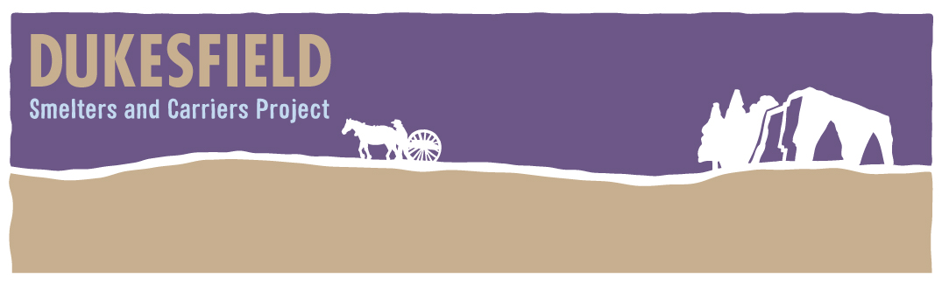
Carry on Mining…Ore
A comedy based in the world of the lead industry of the North East 200 years ago
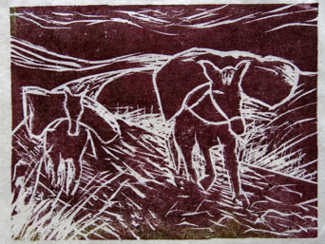
Image from an original print by Ann Watson

Slaley Commemoration Hall
Saturday, Nov 8th, 7–10.00 pm
Adults £8.50 Children £5.50
Family entertainment (age 10 plus). Performed by David Nixon and his company. Three course meal included. ‘Ore’Some Ale on sale at the bar
Tickets: Pat Wilson 01434 673388

All proceeds go towards the running of Slaley Commemoration Hall
