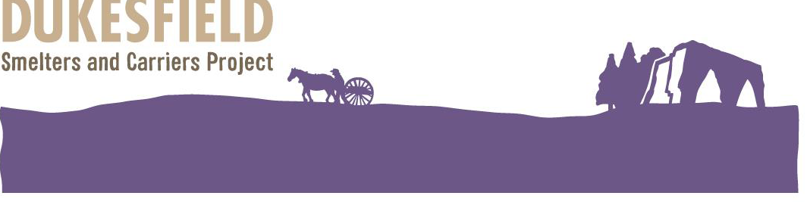
Irish Soda Bread (by Yvonne Purdy)

6 ozs Wholemeal flour
6 ozs Plain flour
dash salt
tea spoon of Bicarbonate of Soda
½ Pint Buttermilk
Make a well in the centre of the flour mixture, add the buttermilk and mix with a wooden spoon until the dough is too stiff to stir. Dust hands with a little flour, then gently knead just long enough to form a rough ball. If the dough is too sticky to work add in a little more flour. Do not over knead. Form a rounded (shaggy) loaf and make a cross on the top. If you over knead, the bread will end up tough. Bake in a moderate over 425C for 35 – 45 minutes until the bread is golden and the bottom sounds hollow when tapped. Soda Bread dries out quickly and is best eaten freshly baked and warm.

History:
Oldest published Irish Soda Bread recipe found was November 1836 referencing an Irish newspaper in County Down. (Note this recipe is made on an open fire using a Dutch Oven which we have on display today thanks to Ian & Pam Forbes). A correspondent of the Newry Telegraph give the following receipe for making “soda bread”, stating that “there is no bread to be had equal to it for invigorating the body, promoting digestion, strengthening the stomach, and improving the state of the bowels.” He says, “put a pound and a half of good wheaten meal into a large bowl, mix with it two teaspoonfuls of finely powdered salt, then take a large tea spoonful of super-carbonate of soda, dissolve it in half a tea cup of cold water, and add it to the meal; rub up all intimately together, then pour into the bowl as much very sour buttermilk as will make the whole into soft dough (it should be as soft as could possibly be handled, and the softer the better,) form it into a cake of about an inch thickness, and put it into a flat Dutch oven or frying pan, with some metallic cover, such as an over-lid or griddle, apply a moderate heat underneath for twenty minutes, then lay some clear live coals upon the lid, and keep it so for half an hour longer (the under heat being allowed to fall off gradually for the last fifteen minutes,) taking off the cover occasionally to see that it does not burn.

Where to buy ingredients
Buttermilk ??

The Dukesfield Smelters and Carriers Project, is led by the Friends of the North Pennines in partnership with Hexhamshire and Slaley Parish Councils and has the active support of the landowner, Allendale Estates. It is funded by the Heritage Lottery Fund and the generous support of other sponsors. Friends of the North Pennines: Charity No: 1137467

