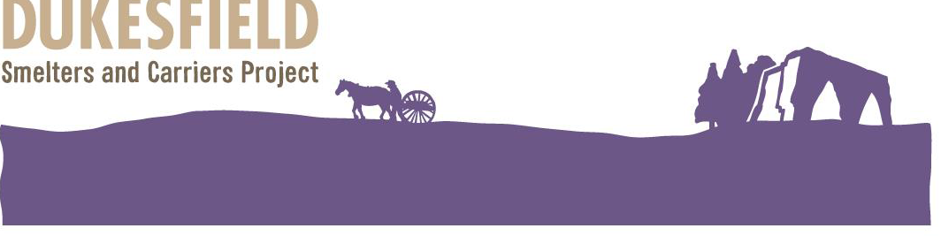

The final dish of the wedding day celebrations The Posset (Traditional Food in Northumberland by Peter Brears)
A portion of white bread soaked in while milk instead of wine, into which the marriage ring was dropped; the bridge and bridegroom tasted the contents first, then the bowls was assailed by the lasses and lads; and whoever ‘fished’ up the ring was accounted to have the best chance of being first married.
4 egg yolks beaten 4 –5 table spoons sugar
¾ pint (450 ml) mild brown ale 2 pints 1.21 cream
3-4 slices of white bread lightly toasted and cut into squares
Beat the egg yolks with a little of the ale, and pour through a sieve into a large pan. Add the cream, remaining ale and sugar, and heat, stirring continuously, until hot, but not curdled (about 80 degrees C), then pour over the toast arranged in a deep bowl, and serve hot. A pinch of nutmeg, mace, cinnamon and ginger may also be cooked with the cream.

1769 Posset
1 pint of thin cream ½ pint of sack (sweet ale similar to sherry)
sugar to personal taste 2 Naples biscuits
1 stick of cinnamon a slice from the end of a lemon
Grate two Naples biscuits into a pint of think cream, put in a stick of cinnamon and set it over a slow fire. Boil it till it is of a proper thickness, then add half a pint of sack, a slice of the end of a lemon, with sugar to your taste. Stir it gently over the fire, but don’t let it boil lest it curdle. Serve it up with dry toast.

History
Originally the Posset was a dessert or drink made from curdled milk enriched with sugar, alcohol (the most popular being sack, a sweet ale similar to sherry). It was often used as a curative for colds or fevers; it is mentioned in the Journal of the House of Lords in the year 1620 that King Charles 1 was given a Posset drink from his physician. These drinks were kept warm and made in a special cup rather like a teapot so that the liquid could be drunk from beneath the foam that develops on the surface. Shakespeare mentions Possets several times in his writings.

Where to buy ingredients
Some supermarkets, health food shops and an off licence or local brewery.
The Dukesfield Smelters and Carriers Project, is led by the Friends of the North Pennines in partnership with Hexhamshire and Slaley Parish Councils and has the active support of the landowner, Allendale Estates. It is funded by the Heritage Lottery Fund and the generous support of other sponsors. Friends of the North Pennines: Charity No: 1137467

