Heritage Open Day at the Arches
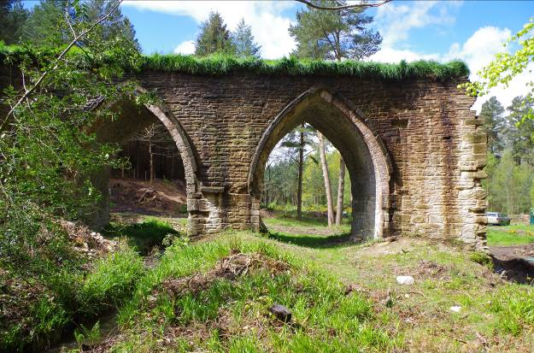
Sunday 14th September, 10 am – 4 pm
Come along to see progress on archaeological digs at the intriguing old lead works near Slaley, NE46 1SG. Project team and volunteer archaeologists on hand to tell you more.
Part of Heritage Open Days. For more information email dukesfield@outlook.com or http://dukesfield.wordpress.com
